Arduino Compatible SD Card ModuleSlot Socket Reader For Mp3 player
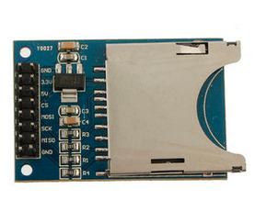
Arduino Compatible SD Card Module Slot Socket Reader For Mp3 player
Description:
This is SD card module slot socket reader for Arduino ARM MCU read write
SD Card Module Slot Socket Reader For Arduino ARM MCU NEW
Make your SD application more easier and simple
It is easily interfaced as a peripheral to your arduino sensor shield module
Through programming, you can read and write to the SD card using your arduino
Can be used for SD Card more easily, such as for MP3 Player, MCU/ARM system control
With all SD SPI Pins out: MOSI, SCK, MISO and CS ,for further connection
Input Voltage: 3.3V/5V
Specification:
Item size:51x304mm
Net weight: 8g
Packaging weight: 18g
Color: Blue

